
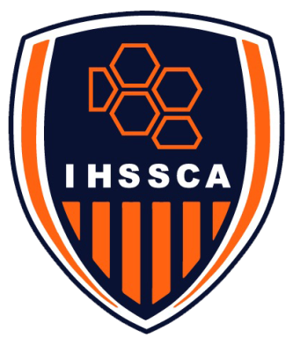


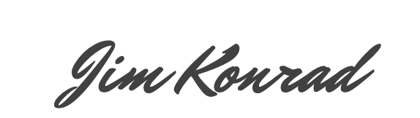
IHSSCA President
GIRLS’ ASSISTANT COACH OF THE YEAR
SECTION XX
SCHOOL NAME
TODAY’S DATE
Date
COACH NAME
This is to certify that the IHSSCA has awarded

